William George "George" Tope
by: Linda Trent
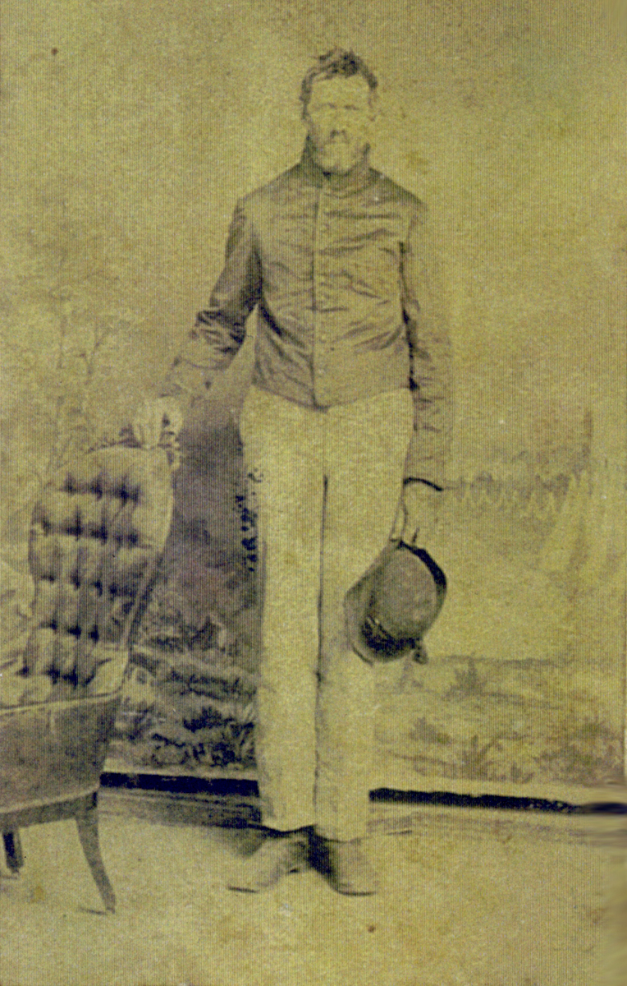
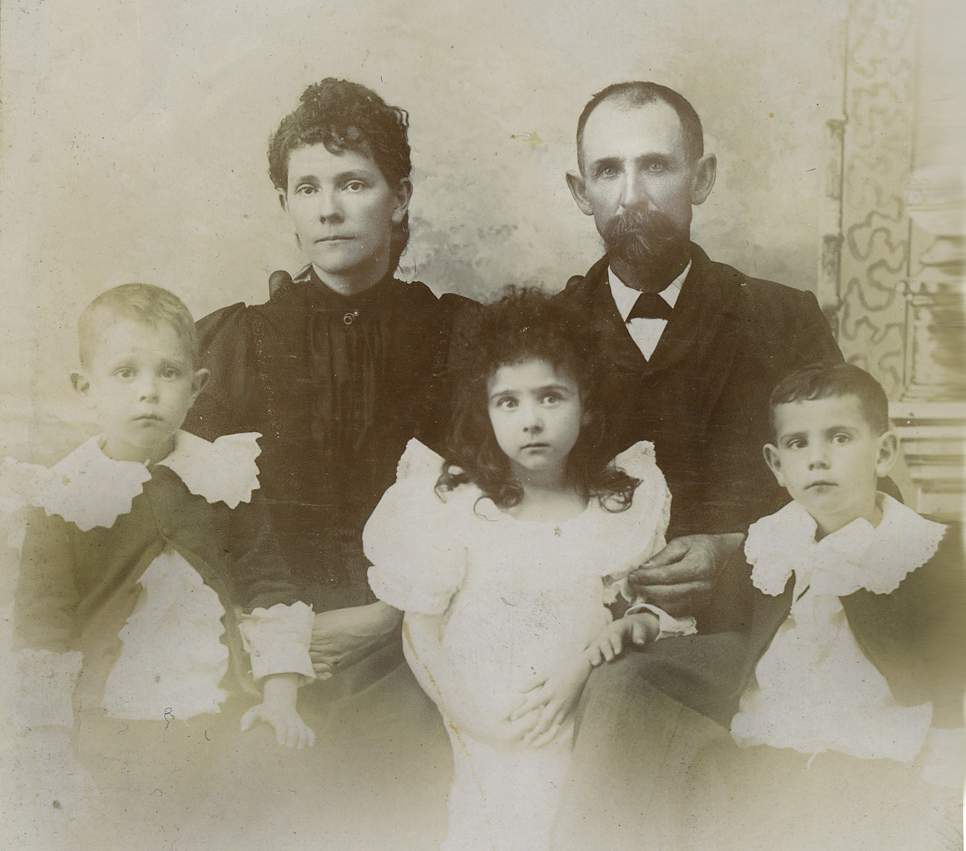
copyright: Sept. 1, 2009

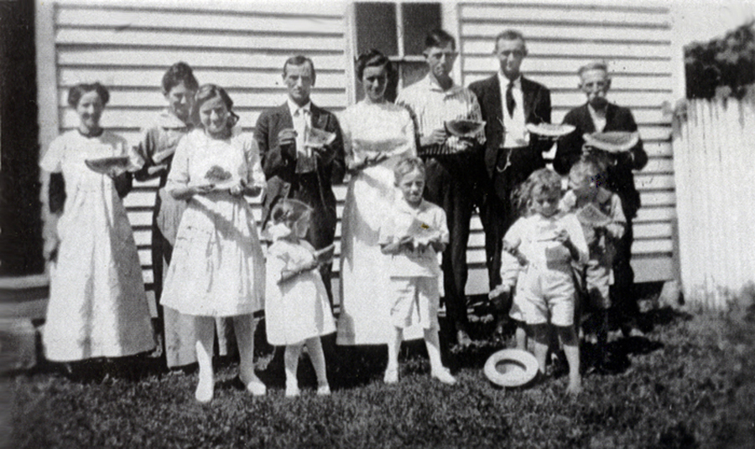
William G. abt. 1864 Mollie Eachus Tope, William G., and Claude, Lillian and Walton

Back Row
Lillian Tope McCall, Mollie Eachus Tope, Albert Tope, Eliza Myers Tope, Claude Tope, Emmett McCall, and Wm. G.
Front Row
Edith Tope, Evelyn Tope, Edward Tope, Cleo McCall. Picture taken in 1915.
William G. Tope was born July 6, 1841 either in Carroll or Harrison County, Ohio. His parents were George W. and Elizabeth Donaldson Tope who were married April 15th 16th, 1840 in Carroll County. He married twice, first to Miss Julia Morgan August 21, 1868, she was the daughter of John and Jemima Merrill Morgan. Julia was born August 6, 1850 and she died August 31, 1885 just six days after giving birth to baby Lucy. William's second wife was Mary Emily Eachus, whom he married April 19, 1887, in Patriot, Ohio, she was born May 14, 1860 or 1861. She was born in Patriot, Gallia County, Ohio.

At some point William's parents moved from Carroll to Harrison County, Ohio. The 1850 census shows the family living in North Township, District 72, Harrison County, Ohio. His father George is listed as a 31 year old male carpenter born in Ohio. Elizabeth [Donaldson-Tope] is listed as a 28 year old female who was born in New York. The children were: William G. age 8 Ohio, Elizabeth age 7 Ohio, John H. age 3 Ohio, and Angeline age 1 born in Ohio.

George W. purchased land in North Township, Harrison County, Ohio from his brother-in-law William Donaldson Jr. (and his wife Nancy) on December 23, 1851. It was the North half of the north-east quarter of section twelve, range six, and township twelve. The interesting thing is, I can't document William Donaldson purchasing the north half (though I'm sure he did, a lot of records never got recorded), though I do have him purchasing the South half. George sold the North half to Mary Ann Myers on November 3, 1853, and 9 days later on November 12, 1853, he purchased land in Gallia County, Ohio. That land was situated in the north west quarter of the north east quarter of section twelve (12) Range sixteen (16) of Township four (4), which is located in Walnut Township, Gallia County, Ohio. This is where William G.
and his siblings continued to grow to adulthood. William's grandfather William Donaldson followed the family to Gallia County purchasing land on February 28, 1854.

1860 census enumeration date June 1, 1860: George Tope age appears to be 46 (should be 41, his birthday July 14), a farmer with $1200 worth of real estate and $300 personal property. He was born in Ohio. Elizabeth is 36 born in Scotland (should be NY). Their children were all born in Ohio: William farmer age 19, Elizabeth 17, John 16, Angeline 14, Mary 12, Richard 10, Margaret 8, Alva 6, and Laura age 2.

On March 27, 1861 George purchased another piece of land, the north-east quarter of the north-east quarter of section 12 range 16 township 4 (40 acres). And on March 25, 1863 he purchased the other quarter, the south-east quarter of the north-east quarter of section 12 range 16 township 4. Combined he purchased 80 acres of land for $1200, this land would be sold to William in a few years.

William was approaching his 20th birthday when on April 12, 1861, Fort Sumter was fired upon, and the Civil War began. Few believed the war would rage on for even a year, let alone 4 years! Finally on August 23, 1862 William went with his friends and enlisted with the 117th Ohio Volunteer Infantry. According to his military records he was 21 years old when he enlisted, 5 foot 8 inches high, dark complexion, blue eyes, dark hair, was born in Gallia County , and was a farmer. He enlisted on August 23, 1862, in Harrison Township, Gallia County, Ohio, for a term of 3 years. On May 2, 1863, the 117th OVI was designated as the 1st Ohio Volunteer Heavy Artillery. During much of the spring/summer of 1863 the companies were on duty in the hills surrounding Cincinnati. William's Company G was at Battery Coombs [pronounced Combs]. Battery Coombs was just one of many batteries built in the Covington area in defense of Cincinnati. I had a chance to climb the hill up to the remains of the old battery, not much left except one can see what appears to be rifle trenching, and the old military road is still well worn, still with little vegetation (presumably caused by the high use and weight of the vehicles being pulled through the area over a sustained length of time).

William kept all of his letters from home. In one dated March 17, 1863, his brother John wrote that his mother wanted him to have two pictures taken, one with his uniform on, and one in civilian clothes. Whether or not the picture on this page was in response to that letter I don't know, but the picture was taken after the request, as the uniform is artillery. He is wearing a Union artillery shell jacket and mounted service trousers, which would be indicative of his service in the artillery as a teamster. Therefore, the picture was most likely taken between November '63 and July '65.

His records prior to November 1863 show him as a private, but in November he appears as a teamster. He's still a private, but he now has different duties. Here's what a March 1863 Harper's Weekly had to say about a teamster: click on 3rd thumbnail entitled “Paying Teamsters.” "A teamster's life is a very hard one, particularly at this season of the year. It does not matter how much it storms, or how deep the mud, subsistence must be hauled to the camps, and day and night, toiling along with tired horses and mules, the creaking wagons are kept busy carrying to and fro commissary, quarter-master, and ordnance stores, in addition to keeping the camps supplied with fire-wood. White teamsters have $25 a month."

So "no matter how much it storms..." In January 1864 the regiment was ordered from the Covington area to Knoxville, Tennessee. This meant going over the mountains in heavy snow. The battallions rendezvoused at Camp Nelson in Jessamine County, KY. , and started for Knoxville on January 25th, 1864, their path followed what is now KY St. Rte 27. Their first night was at Camp Dick Robinson in Garrard County, their third was at Hall's Gap. On January 30th, they arrived at Point Burnside on the Cumberland River. Here they stayed for nearly a month leaving on February 28, 1864. At this point "there were not many roads and wagons could not be used! So that in the transportation of supplies for man and beast, pack muleshad to be used... The route over which the regiment traveled was the same traversed by Burnside in 1863.

Also, H.C. Miller, the regimental historian (an original member of the regiment), mentioned a man with the 10th Michigan Cavalry, so I looked that regiment up and found another account of the same march, this one explains why they stayed for a month at Point Burnside, and where they came out of the mountains, Jacksboro, Campbell County, TN (to see Campbell see footnote).

The companies were split up to different duties. Some were on guard duty while others were taken to accompany Sherman on his march to the sea. William's company remained on guard duty in Tennessee. From Knoxville his company was detached to guard the railroad at Strawberry Plains, the image that this link leads to is from Nov./Dec. 1863, that is about 8 months before William's company arrived at Strawberry Plains. Here's another original photograph that I found of Strawberry Plains.

In Nov/Dec. 1864 William was sick in the hospital at Knoxville. Finally 1864 gave way to 1865 and the end of the war. What began April 12, 1861 ended April 9, 1865, five days later Lincoln was assassinated at Fords Theater, in Washington. Company G of the 1st OVHA was at Blue Springs, Greene County, TN when they got the joyous news of the war's end; and then the tragic news of their beloved President Lincoln's death. They were mustered out in Knoxville, Tennessee on July 25, 1865, and went home.

William purchased some land in Gallia County from his father on September 6, 1865. He purchased the whole 80 acres that his father purchased in 61 and 63, only his father paid a total of $1200 for the land, but sold it to William for only $750.

William married Julia Morgan on August 17, 1868, in Gallia County, Ohio.

1870 census enumeration date June 1, 1870 William is listed as George Tope farmer age 28 and wife Julia keeps house age 19. He's valued at $900 worth of real estate and $300 personal property. Both [William and Julia] were born in Ohio. He lived right next door to his parents, and two doors down from her widowed mother. Based on the enumeration date and birthdates, this information is entirely correct.
Together they had six children: Ebert, Bertha, Hattie, Albert, Nelson, and Lucy.

1. Ebert Curtis Tope was born November 7, 1870, in Walnut Twp., Gallia Co., Ohio. Ebert married Effie J. Shoemaker (daughter of John L. and Rachel [illegible] Shoemaker of Harrison Township, Gallia County, Ohio on April 1, 1903.

2. Bertha Anatte Tope was born December 29, 1872, in Walnut Twp., Gallia Co., Ohio. She married Ulysses Minor on April 26, 1892. There is a Ulysses S. Minor who was born in 1870 and died in 1903 and is buried at White Cemetery, Harrison Township, Gallia County.

3. Hattie Tope was born April 1, 1876, in Walnut Twp., Gallia Co., Ohio. Hattie married Arthur Bruney on June 15, 1905, probably in Fairfield County where (according to the 1900 census) she was a servant for the Bouman family. She died September 24, 1970 in Fairfield County, Ohio.

4. Albert Eben Tope was born April 11, 1878, in Walnut Twp., Gallia Co., Ohio. He married Eliza J. Myers (daughter of James Myers and Laura Elliot) on December 25, 1901. I am personally grateful to Albert for the wonderful Tope Family History that he wrote. It is one of the four Tope histories that I have in my collection, and the only one that followed my own personal lineage. Albert was my half-granduncle. Albert died Saturday January 8, 1966.

1880 census enumeration date June 1, 1880. Here William and Julia continue to show up next door to George W. and Elizabeth (his parents). "William G. Tope" age 39 married, farmer, born Ohio, father Ohio, mother New York. "Julia E." age 29 wife keeping house, she was born in Ohio and both parents were born in Virginia. Their children were all born in Ohio as were their parents. Ebert C. age 9 son, at school; Bertha A. age 7 daughter, at school; Hattie 4, daughter, at home; Albert E. age 2 son, at home. The family also had a white servant Saphrona A. Sigler age 18, born in Ohio as were both her parents.

5. Nelson Tope was born November 17, 1881, in Walnut Twp., Gallia Co., Ohio. Nelson married Sylvia Brown on June 6, 1906, and he died November 25, 1947.

6. Lucy Julie Tope born August 25, 1885, in Walnut Twp., Gallia Co., Ohio. Died September 21, 1885. The following paragraph tells the story of a great anguish.

William's life seemed to be going well, when tragedy struck. On August 25th, 1885 Julia gave birth to her last child Lucy Julie Tope, six days later Julia died from complications of childbirth (August 31). Infant Lucy followed her mother to the grave 21 days later, on September 21, 1885. I can't imagine the pain the family must have gone through losing Julia, and then having a weak infant and watching it hold on to life for three weeks without a mother.
William married again, this time to Mary Emily "Mollie" Eachus on April 19, 1887.
1. Lillian Gladys Tope was born January 29, 1888. She married Emmet G. McCall (son of James McCall and Lucinda Folden) on February 12, 1908. She died October 18, 1972 in Gallipolis, Ohio. Emmet died March 24, 1952.

2. Claude Oswald Tope was born September 9, 1889. He married Margaret O'Dell (daughter of John O'Dell and [Rhonda] Christina Jacox) on October 22, 1910. He died August 7, 1973 in Bidwell, Gallia County.

1890 Veterans' Census Ancestry mistakenly has him identified as William G. Taper. But he's William G. Tope Private Company G 1st Ohio Heavy Artillery. Enlisted August 20, 1862, discharged June 20, 1865, 3 years service. He had no reported disability due to the war. The date of enlistment and discharge are slightly off.

3. Walton Stanley Tope was born August 23, 1890. According to his birth certificate he was born in July, but that is not correct. He married Bessie Mae Hixon on April 16, 1919 in Springfield, Clark County, Ohio. He died February 24, 1963 in London, Madison County, Ohio. Bessie died January 17, 1951 at Grant Hospital in Columbus, Franklin County, Ohio. They are both interred at Mound Hill Cemetery in Gallipolis.

1900 Census enumeration date June 1, 1900. William G. Tope head of household, born July 1841 age 58 and married for 12 years. He was born in Ohio as was his father, and his mother was born in New York. He was a farmer, could read, write and speak English, and owned his own home/farm mortage free. His wife was Mary and she was born May 1862, she was 38 years old and was the mother of three children (all 3 still living). Both she and her parents were all born in Ohio, and she could read, write and speak English. Their children were all born in Ohio. Albert, son, April 1878 age 22 at school 3 months not employed 9 months in school. Nelson, son, Nov. 1881 age 18 farm laborer 0 months not employed 3 months in school. Lilian, daughter January 1888 age 12 6 months in school. Claudie, son September 1887 age 10 farm laborer 3 months not employed, 6 months in school. Walten, son, August 1890 age 9.

1910 census. Tope, W. George Head 69 years old married 22 years William and both parents born in Ohio. He's a farmer and owned (free and clear) a general farm which he worked on his own account. He could read and write. Mollie E. wife 49 years old had three children, 3 still living, Mollie and both parents born in Ohio. She keeps house. Claudie O. son 20 and Walton S. son 19 both single, both were born in Ohio as were their parents, both worked on father's farm, though Walton looks like he attended school "since September 1, 1909."

William George Tope died January 13, 1918 in Walnut Township, Gallia County, Ohio. His obituary in the Gallipolis Tribune reads as follows:

“Death of W. G. Tope. W. G. Tope passed away at Northup, Sunday night, Jan. 13, 1918, after several months illness with complications.

He was 75 years old, a veteran of the Civil War, and a resident of Gallia county all his life. He was a man well liked by all who knew him, and a prominent farmer for years, and a large number of friends mourn his death.

The deceased is survived by his widow Mrs. Mollie Eachus Tope and three children, Mrs. Lillian McCall of Clay Lick, Walton at London, O., and Claude at home, and five by a former wife, Mrs. Hattie Brumey of Lancaster, Mrs. Bertha Minor of Adamsville, Nelson of Springfield, Everett of Canton, O., and Albert of Patriot.

Three sisters and three brothers survive.

The funeral will be conducted at 10 a.m. Tuesday from the home with interment in charge of Myers.”

However, the funeral was postponed a day “on account of some of the children not being able to get here.”

His death certificate gives his father’s name as “Geo. Wm. Tope.”

Nickname "George" 1870 census has him as George and Julia Tope. 1910 census "W. George and Mollie Tope"
Original Photograph owned by Audrey Johnson
Original Photograph owned by Earl Tope
Original Photograph owned by Earl Tope
The family Bible of his parents George W. and Elizabeth Donaldson Tope (Xerox handed to me by Joan Redondo at the Tope family reunion in Gallipolis on June 2, 2007).
The family Bible of William G. and Mollie Eachus Tope currently owned by a Gallia County cousin -- Anita.
William G's account book owned by another Gallia County cousin – Audrey.
I believe he was most likely born in Carroll County as his parents were married there a year two months and 21days earlier, and proof of residence there was the 1840 census.
Is another possibility depending upon when his parents moved, as they show up next in the 1850 Harrison County, Ohio census, in fact he's listed as "do" Harrison County on the 50 census, but that may have just been the enumerator getting excited, note he had to change Elizabeth from "Do" to NY.
Gallia. I firmly believe is not a possibility even though William, himself, apparently gave Gallia on his military records. The earliest I have either the Tope or Donaldson family in Gallia is 1853 see footnotes ³¹ & ³² I feel he said he was born in Harrison and since they were being organized in Harrison Twp, the recruiter put Gallia County.
The family Bible of George W. and Elizabeth Donaldson Tope
1850 census. Ohio, Harrison, North, Pg. 19
His father's will Gallia County Civil Case No. 1990, Vol. E pg. 190. The will is located in paper form at the "Gallia County Historical and Genealogical Society" in Gallipolis, Ohio.
Carroll County Marriages Vol. 1 Page 143 #9253
The family Bible of George W. and Elizabeth Donaldson Tope
Gallia County Marriage Records Vol. 3 Pg.237
Estate of John Morgan, Gallia County Probate Court E-1868 Civil Journal 2 Pg. 161 CM 130
William G's account book see footnote ⁷
Gallia County Death Records August 31, 1885
I do not know for sure where the “Emily” comes from, as it does not appear in any of the primary source material that I seem to own. I do know that it is at least oral history from the elders at reunions that I’ve personally attended.
Gallia County Marriages Vol 6 Pg. 297
Patriot comes from William G. and Mollie's family Bible see footnote ⁶
William G's account book owned by another Gallia County cousin
The family Bible of William G. and Mollie Eachus Tope. I believed the Bible to have an 0 with a 1 over it. With the coming forth of William’s account book I believe it was actually a 1 with an 0 over it. She was born in 1860.
State of Ohio Death Certificate informant “Albert Tope” mortician, step-son, and Tope historian.
The Gallia Times, obituary, Thursday, February 19, 1942
1850 census. Ohio, Harrison, North, Pg. 19
Harrison County Deeds Book O Pg. 348
Harrison County Deeds Book N Pg cut off
Harrison County Deeds Book O Pg. 658
Gallia County Deeds Book Vol. 25 Pg. 422
Gallia County Deeds Book 25 Pg. 509 N-W quarter of S-E quarter of Sect. 13, Twp. 4, Range 16 and S-W quarter of N-E quarter of section 13, Twp. 4, Range 16
1860 census Ohio, Gallia, Walnut, Pg. 23
Gallia County Deeds Vol. 34 Pg. 130 March 27, 1861
Gallia County Deeds Vol. 34 Pg. 131 March 25, 1863
Gallipolis Journal Sept. 11, 1862 (contains a complete list of volunteers who joined the 117th OVI).
William G's service records from the National Archives. [1st Ohio Volunteer Heavy Artillery, formerly the 117th OVI]
I firmly believe is not a possibility even though William, himself, apparently gave that on his military records. The earliest I have either the Tope or Donaldson family in Gallia County is 1853
William G's service records from the National Archives.
Check Ohio In the War
original letters owned by Audrey Johnson, copies of original letters in my possession
William G’s service records from the National Archives.
http://www.campnelson.org/introduction.htm
http://www.sonofthesouth.net/leefoundation/civil-war/1862/november/camp-dick-robinson.htm
http://parks.ky.gov/findparks/recparks/ge/history/
117th’s March over the Mountains. H.C. Miller, Regimental Historian for the 117th OVI/1st OVHA. http://www.galliagenealogy.org/Military/117ovihistory.htm
History of the Tenth Michigan Cavalry, Pg. 9-10 on Ancestry.com
I can't get Campbell to call up without calling up Anderson, then in neighboring counties, click on Campbell and it will come up.
http://images.google.com/imgres?imgurl=http://www.shorpy.com/files/images/02140u.preview.jpg&imgrefurl=http://www.shorpy.com/node/2021&usg=__R248ko8dvigiTBCRBsF7Y6QxygY=&h=501&w=512&sz=86&hl=en&start=14&um=1&tbnid=EWs02Bj7Sf51tM:&tbnh=128&tbnw=
http://images.google.com/imgres?imgurl=http://www.old-picture.com/civil-war/pictures/Knoxville-Tennessee-001.jpg&imgrefurl=http://www.old-picture.com/civil-war/Knoxville-Tennessee-Strawberry-Military.htm&usg=__eUDBmm-PSbbA9kBEHNbvt6Hw31s=&h=634
Gallia County Deeds Book Vol. 36 Pg. 29
Gallia County Marriage Records Vol. 3 Pg.237
1870 census Ohio, Gallia, Walnut, Pg. 19
William G's account book
Gallia County birth records have his name recorded as “Egbert C”
Gallia County Marriage Records Vol. 10 Pg. 82
William G's account book
Bertha’s name was recorded in the Gallia County birth records as Ida Floid
William G's account book
William G's account book
Albert was unnamed Tope in the Gallia County birth records, where his date of birth was recorded as April 10, 1878.
Gallia County Marriage Records Vol. 9 Pg. 479
Ohio Death Records 1958-2002 on ancestry.com
C.J. Waugh Funeral Home. Father’s name really should read William G. Tope, and mother should be Julia Morgan, and not Julia Donaldson. Donaldson is William G’s mother’s maiden name.
William G's account book
William G's account book
Gallia County Marriages Vol 6 Pg. 297
Gallia County Marriage Records Vol. 11 Pg. 191
Gallia County Marriage Records Vol. 11 Pg. 543
The family Bible of William G. and Mollie Eachus Tope.
William G's account book
Clark County Marriage Records Vol. 28 Pg 397 #12516
WWI Draft Registration Card ancestry.com
State of Ohio Death Certificate on familysearch record search pilot.org (a free site) with Ohio death certificates.
Gallipolis Tribune, January 18, 1918, on microfilm at Bossard Memorial Library Gallipolis, Ohio.
January 17, 1918 Gallipolis Journal on microfilm at Bossard Memorial Library Gallipolis, Ohio.
when page calls up type in William George and Tope death 1918 Ohio exact match and click search. To the left of William’s name is a tiny page, if you click on that the original image will call up. Informant was Harry Tope of Northup, Ohio. Most likely Harry Washington Tope, son of John H. and Mary Huron Tope and grandson of George W. and Elizabeth Donaldson Tope. Harry W. was actually born on Washington’s birthday February 22, 1879, and died May 13, 1956 in Northup. The information in this footnote is important only because there has been some discussion as to George W. Tope’s middle initial. Agreeing with George William Tope is Albert Tope, who wrote the Tope family history, and like Harry W. was a grandson of George W. Albert was born Apr. 11, 1878 and died January 8, 1966. However, disagreeing with both Harry and Albert is George W’s obituary in the Gallipolis Journal of August 17, 1898 which W. H. Tope gives George W’s middle name as Washington. W.H. is believed to be Rev. Willam Henderson Tope also son of John H. and Mary Huron Tope, and grandson of George W. Tope. William H. was born Feb. 21, 1871, died May 1, 1948. Wm. G is the only child to have his father’s full name put on his death certificate. So there is nothing else to compare with this information. Unfortunately there are no legal documents, letters, etc. He always signed his name as “George W.” or “G.W.” I have not found any paperwork where he personally gives his middle name, so it is up for debate. So who’s right? We may never know for sure, but I do have my own theory. Having attended the many Tope family reunions here in Gallia County, I have always heard that William G. was just his father’s name reversed. It is also my belief that Harry Washington would have taken some pride in sharing the same middle name as his grandfather, but instead put on William G’s death certificate his father was George Wm. Of course Wm is an abbreviation for William. Unlike Harry, George was not born on Washington’s birthday. My feeling is that William Henderson made a mistake, and that Harry and Albert were right, but other’s opinions may vary.

